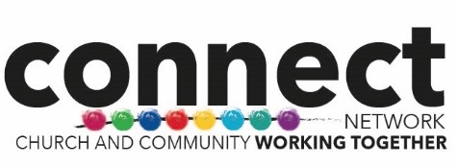

Connect Network Statement of Faith

Christians in Connect Network acknowledge God’s revelation in Christ, confess the Lord Jesus Christ as God and Saviour according to the Scriptures, and, in obedience to God’s will and in the power of the Holy Spirit, commit themselves to fulfil their mission to proclaim the Gospel by common witness and service in the world, to the glory of the one God, Father Son and Holy Spirit.

